# Name-Aditya Vinayak Patil

Div- SE A Roll No-42

# Experiment no. 4

**Aim:** Create a Child Process in Linux using the Fork system call. From the Child

a) Process Obtain the Process ID of Both Child n Parent by using getpid and getppid system Call.

Calling fork()

**Sources code :**

#include <stdio.h>

#include <sys/types.h> #include <unistd.h>

int main()

{

fork();

printf("Using fork() system call\n"); return 0;

}

**Output:**

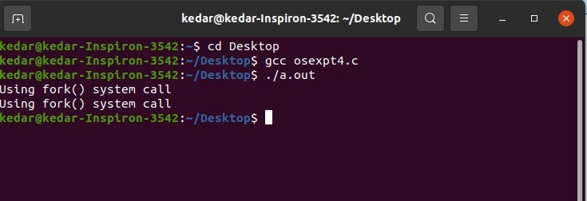

# Experiment no. 4

**Title:** Program to Obtain the process ID of both child n parent by using getpid and getppid system calls.

**Source Code:**

#include<stdio.h>

#include<stdlib.h>

#include<unistd.h>

#include<sys/types.h>

int main(int argc, char **argv)

{ pid_t pid; pid = fork(); if(pid==0)

{

printf("It is the child process and pid is %d\n",getpid()); **//getpid() - will return process id of calling function**

exit(0);

}

else if(pid > 0)

{

printf("It is the parent process and pid is %d\n",getppid()); **//getppid() - will return process id of parent function**

} else

{

printf("Error while forking\n");

exit(EXIT_FAILURE);

} return 0; }

**OUTPUT :**

